Asian Journal of Management Review

Please cite this article as:

EXPLORE THE OVERCOMING OBSTACLES ON THE ENTREPRENEURIAL JOURNEY AMONG ENTREPRENEURSHIPS WITH DISABILITIES IN SELANGOR area

Syazana Sabaruddin*, NorHaninah AGhani
Corresponding author*

Kl2207011281@student.kuptm.edu.my
norhaninah@uptm.edu.my
Received xx April 2024, Accepted xx April 2024, Available online xx May 2024

ABSTRACT

"Entrepreneurship for Empowerment Persons with Disabilities" emphasizes the importance of supporting disabled entrepreneurs in Malaysia for their economic independence and societal integration. This study examines the hurdles, available support systems, and areas for improvement within Malaysia's entrepreneurial sphere for people with disabilities. It investigates whether disabled individuals engage in entrepreneurship out of passion or due to limited job opportunities, exploring challenges such as financial limitations, societal prejudices, and insufficient resources. Offering suggestions to improve success rates, the research aims to encourage positive shifts in policies and attitudes, providing targeted aid for disabled entrepreneurs in Selangor. This research theme delves into the obstacles confronted by disabled entrepreneurs on their entrepreneurial journey in Selangor. It explores their challenges, methods for business establishment and growth, and the determination shown in navigating societal biases, financial constraints, and limited resource accessibility. Through qualitative interviews with disabled entrepreneurs in Selangor, the study seeks to uncover their experiences, motivations, and unique barriers. The findings will guide the creation of policies and programs to empower disabled entrepreneurs, cultivating a more supportive entrepreneurial landscape in Selangor.

Keywords: Entrepreneurship, Disabilities, Challenges, Qualitative Research, Empowerment

- INTRODUCTION
In "Entrepreneurship for Empowerment Persons with Disabilities," the (AlContentfy team, 2023) draws attention to the burgeoning potential of entrepreneurship for individuals with disabilities in Malaysia. The concept of entrepreneurship empowerment is highlighted, describing the process of providing individuals with the tools, resources, and mindset necessary to embark on entrepreneurial ventures. This empowerment grants individuals the autonomy and confidence to shape their destinies, cultivate innovative ideas, and establish viable businesses.
The study underscores the importance of supporting entrepreneurs with disabilities, emphasizing its role in not only fostering economic independence but also promoting a more inclusive society. The research aims to delve into the Malaysian entrepreneurial landscape for individuals with disabilities, with a focus on understanding the challenges they face, the existing support systems, and the need for advancement in their entrepreneurial pursuits.
Within the context of exploring the hurdles faced by entrepreneurs with disabilities in Selangor, the problem statement centers on understanding whether individuals embark on entrepreneurship out of passion and commitment or due to the lack of suitable employment opportunities. The study seeks to identify and analyze the specific obstacles encountered by disabled entrepreneurs, including financial constraints, societal perceptions, geographic accessibility issues, and inadequate business resources (Hamdan, 2023; Hamdan et al., 2023; Jalil, 2021; Rodzi, 2024).
(Mills, 2023) further discusses this theme, emphasizing that overcoming obstacles in entrepreneurship entails accepting multiple failures, daring to do things differently, and navigating uncertainties about outcomes. The research aims to explore how disabled entrepreneurs in Selangor navigate these challenges, shedding light on their resilience, determination, and the strategies they employ to achieve success despite adversity. This article review will delve into the insights provided by these studies, aiming to inform further research and contribute to policy changes and targeted support for disabled entrepreneurs in Selangor.

2.0 LITERATURE REVIEW

2.1 Challenges of Disabilities Entrepreneur
The systematic review titled "The Challenges of Disabled Entrepreneurs" thoroughly investigates the unique obstacles faced by entrepreneurs with disabilities. This study aims to carefully examine the existing literature regarding the challenges confronted by disabled individuals in their entrepreneurial pursuits, with a particular focus on their motivations and the hurdles they encounter. It sheds light on various factors such as financial constraints, social support systems, regulatory barriers, gaps in business knowledge, and biases prevalent in the market (Azizan, 2021; Hamzah, 2022; Shuhaimi, 2021).
By analyzing ten articles sourced from reputable databases, the review uses the Preferred Reporting Items for Systematic Reviews and Meta-Analyses (PRISMA) guidelines to systematically organize the research field. The study emphasizes the urgent need for further exploration to craft effective policies and interventions that facilitate the engagement and success of disabled entrepreneurs within the broader entrepreneurship landscape. (Norliza, The Challenges of Disabled Entrepreneurs: A systematic review, 2023)
The literature review delves into the intricate challenges faced by disabled entrepreneurs, particularly emphasizing the financial and social barriers impeding their entrepreneurial ventures. Financial obstacles encompass difficulties in securing funding, the exorbitant costs associated with medical care and assistive technologies, and the limited access to financial resources and government assistance programs. Social challenges include feelings of isolation, experiences of discrimination, negative societal attitudes, restricted access to business networks and mentorship, and encountering harmful stereotypes from clients, investors, and partners.
Acknowledging the necessity for tailored policies, programs, and interventions to address these challenges, the study advocates for the establishment of a more inclusive and supportive entrepreneurship environment for individuals with disabilities (bin Othman et al., 2024; Hamdan et al., 2023; Mustapha & Seman, 2023). Additionally, the research identifies gaps in the current literature, underscoring the importance of further exploration to effectively bolster support for disabled entrepreneurs and enhance their participation in the business realm. (Norliza, The Challenges of Disabled Entrepreneurs: A systematic review, 2023)
In conclusion, the systematic review provides valuable insights into the myriad challenges faced by disabled entrepreneurs, stressing the pressing need for more comprehensive research and the formulation of effective policies to tackle these impediments (Jamaludin et al., 2024, 2025). It calls for a collaborative effort from governmental bodies, agencies, policymakers, and industries to mitigate resource disparities and champion the inclusion and prosperity of disabled entrepreneurs within the entrepreneurial landscape. Ultimately, the study highlights the importance of fostering an entrepreneurial culture that embraces diversity, empowering individuals with disabilities to unleash their full potential as successful business owners. (Norliza, The Challenges of Disabled Entrepreneurs: A Systematic Review, 2023)

3.0 METHODOLOGY
3.1 Research Design
In this study, a qualitative research design was employed to investigate the employment landscape for individuals with disabilities in Malaysia. The use of guided semi-structured interviews as the primary data collection method offered a flexible and focused approach. Semi-structured interviews, as explained by (George, 2022), involve questions within a predetermined framework, allowing for adjustments in wording and sequence to delve deeper into respondents' perspectives. This method is widely utilized in disciplines such as marketing and social science to gain a nuanced understanding of participants' beliefs and experiences. (Dovetail, 2023)
Participants were encouraged to share their insights on how individuals with disabilities can establish income sources or partake in entrepreneurial activities. The open-ended nature of these interviews facilitated the gathering of detailed and insightful accounts, providing a rich understanding of the challenges and opportunities faced by disabled individuals in the realm of entrepreneurship.

3.2 Research Sampling
This study delved into the experiences of entrepreneurs with disabilities in the Selangor region, chosen for practicality. Employing a maximum diversity sampling approach suited for semi-structured interviews, the study aimed to gather a wide range of perspectives. Snowball sampling, a non-probability method, was utilized to expand the sample size. This technique, starting with initial participants and then relying on referrals, continued until saturation was achieved. (Nikolopoulou, 2023)
Snowball sampling proved invaluable for reaching populations that might otherwise be hard to access, particularly marginalized groups such as the homeless. Participants were encouraged to refer others they trusted, facilitating data collection. (Nikolopoulou, 2023)
The study's initial participant offered numerous referrals, each of which was thoroughly explored to gather sufficient data. The objective was to reach a "saturation point," indicating that further participants would likely echo existing findings. Through this method, the study ensured a diverse array of perspectives from disabled entrepreneurs in the Selangor region, providing valuable insights into their experiences in entrepreneurship.
3.3 Method of Conducting Qualitative Research
3..4.1 Research Participants
The interview questions were tailored to the research objectives of empowering individuals with disabilities through entrepreneurship. They aimed to understand the perspectives of disabled individuals on their entrepreneurial engagement and gather insights on enhancing their success. Initially prepared in English, participants had the option to communicate in Bahasa Melayu for better comprehension.
From February 26, 2024, to March 9, 2024, three entrepreneurs with disabilities were interviewed. Despite the small sample size, the depth of information gathered was substantial, supporting the study's conclusions. Interviews were conducted informally, with participants briefed on the study's aims beforehand. Probing questions were used to delve deeper into their responses. Each session lasted around an hour and was recorded on video.
The study included three entrepreneurs with disabilities, each chosen to provide diverse insights into entrepreneurship challenges and successes within this demographic. Mr. Azizi Latif Bin Abdul Latif, a painter with a physical hand disability; Puan Nor Zaidah Binti Ab Rahman, who runs a tailoring business; and Mr. Mahmud Bin Rasul, a cookie-selling entrepreneur with a half-body stroke. Chosen for their diverse experiences, they offered valuable insights into the challenges and successes of entrepreneurship for disabled individuals.

3.4.2 Data Analysis Approach
Thematic analysis was the chosen method for analyzing the data in this study. This approach is commonly used in qualitative research, particularly with textual materials such as interviews or transcripts. The researcher carefully reviewed the recorded interviews, looking for recurring themes consistent topics, ideas, and patterns of meaning. (Caulfield, 2019)
Initially, the interviews were transcribed verbatim, creating a dataset of text for analysis. The data then underwent a structured analysis process where segments were identified and labeled with descriptive codes representing key concepts or ideas. These codes were further organized into potential themes based on commonalities and connections observed in the data. Through an iterative review process, these themes were refined to accurately capture the essence of the data.
The resulting themes were then interpreted and presented in the study's findings, aiming to provide a comprehensive understanding of the experiences, challenges, and perspectives of individuals with disabilities in the context of entrepreneurship and empowerment. Thematic analysis was employed to offer valuable insights and contribute to the existing body of knowledge in this important research area.

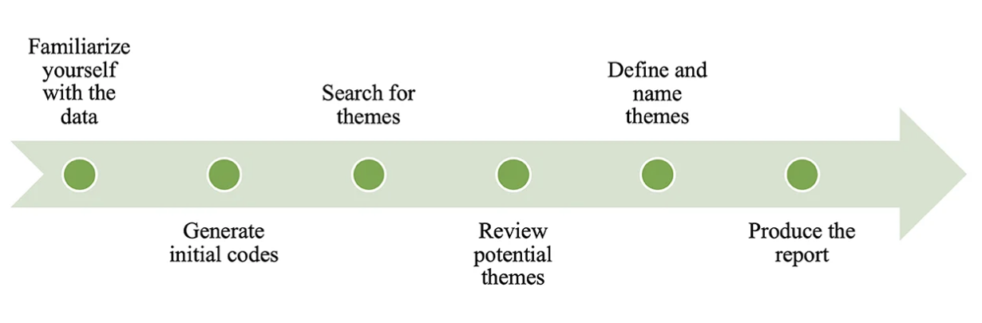
Figure 1: Process of Thematic Analysis for this study

Steps for conducting thematic analysis:
- Transcription of Data: Begin by converting the interview recordings or written material into text. This involves turning spoken words into written form to facilitate analysis.
- Getting Acquainted with Data: Engage with the raw text, familiarizing oneself with the transcribed content. Take notes, highlight key points, and recognize any initial patterns or thoughts that stand out.
- Creating Initial Codes: Initiate the coding process by pinpointing and labeling text segments that align with the research questions or themes of interest. Assign descriptive labels or codes to these segments.
- Identifying Potential Themes: Analyze the coded segments, grouping them into potential themes or patterns. Look for recurring ideas, concepts, or subjects that consistently emerge from the data.
- Refining and Defining Themes: Further develop and define the research themes using the coded segments, ensuring that each theme captures a distinct aspect of the data. Confirm that the themes are clear and meaningful.
- Interpreting Data: Interpret the themes by exploring how they relate to the research objectives and the insights they provide. Consider the broader implications of each theme within the study's context.
- Presenting Findings: Document the analyses by presenting the identified themes, supported by relevant quotes or examples from the data. Elaborate on each theme and discuss its significance in connection to the research questions.

4.0 FINDINGS AND DISCUSSION
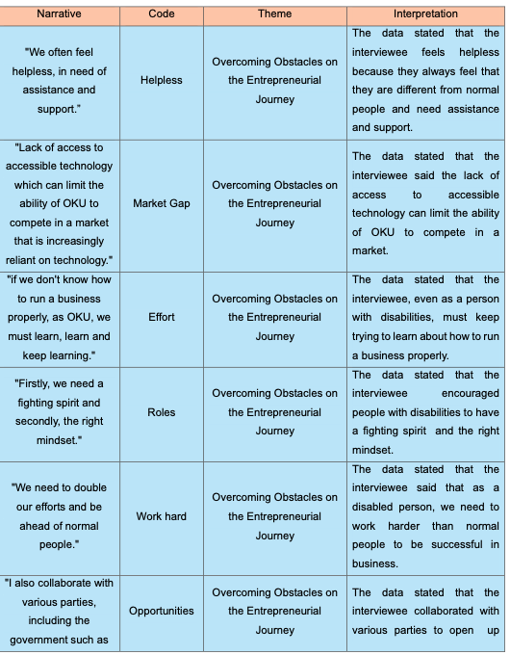

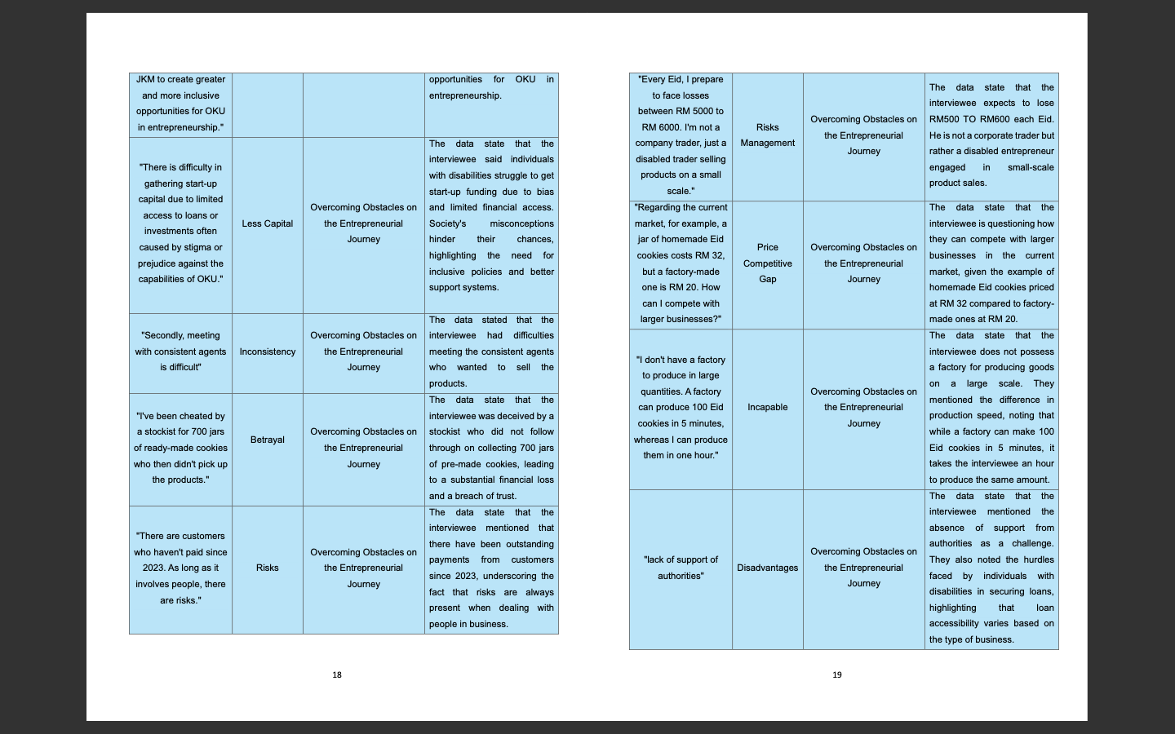

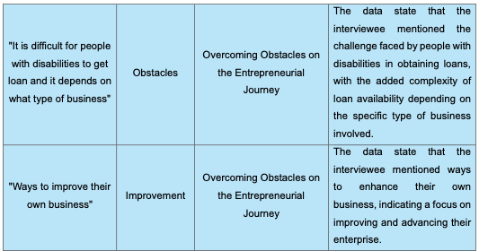

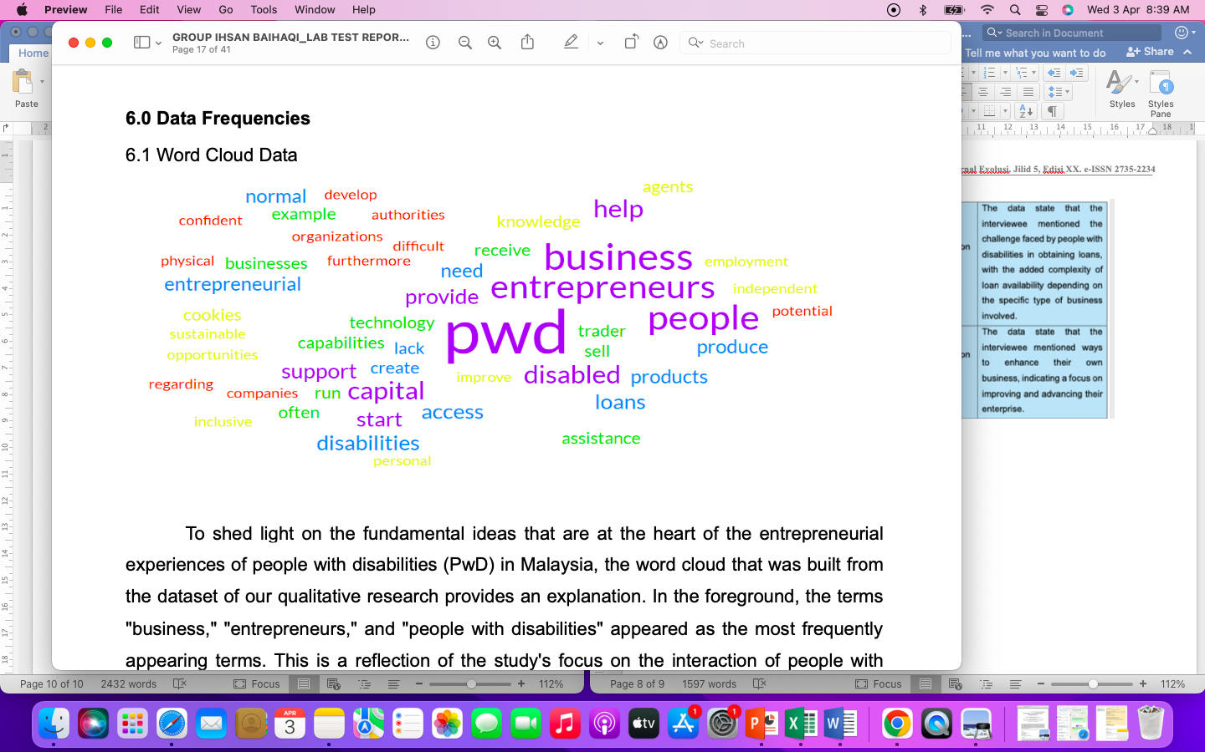

In this research, the chosen themes have been carefully selected to offer a thorough understanding of the experiences, hurdles, and viewpoints of disabled individuals in the realms of entrepreneurship and empowerment. Through a detailed analysis and subsequent discussion, the study aims to shed light on the unique challenges faced by disabled entrepreneurs, including financial limitations, social support structures, regulatory complexities, knowledge gaps in business operations, and prevalent market biases. These themes have been thoughtfully curated to delve into the complex challenges confronted by disabled entrepreneurs, highlighting the pressing need for further exploration. The study advocates for the development of effective policies and interventions to support the involvement and success of disabled entrepreneurs within the broader entrepreneurial landscape. By focusing on these themes, this research seeks to guide future studies and contribute to the creation of policies and targeted support mechanisms for disabled entrepreneurs in Selangor, Malaysia.

5.0 CONCLUSION

"Entrepreneurship for Empowerment Persons with Disabilities" accentuates the crucial support needed for disabled entrepreneurs in Malaysia. By thoroughly scrutinizing the entrepreneurial landscape, this study has revealed the intricate challenges faced by individuals with disabilities, spanning from financial limitations to societal biases. By investigating whether disabled individuals are driven towards entrepreneurship by passion or necessity, this research unveils the complex hurdles they confront, including limited resources and societal perceptions.
The comprehensive review of existing literature illustrates that disabled entrepreneurs encounter formidable barriers, ranging from securing financial backing to accessing business networks. Nevertheless, amidst these obstacles, their resilience shines as they forge paths to success. The study advocates for customized policies and interventions to cultivate a more inclusive entrepreneurial environment, one that empowers disabled individuals to flourish.
The qualitative methodology embraced in this study, inclusive of interviews with disabled entrepreneurs in Selangor, provides invaluable insights into their experiences, motivations, and strategies for surmounting challenges. The diverse array of perspectives shared by participants such as Mr. Azizi Latif Bin Abdul Latif, Puan Nor Zaidah Binti Ab Rahman, and Mr. Mahmud Bin Rasul underscores the diverse landscape of disability entrepreneurship.
Through thematic analysis, this research sets the stage for future investigations to delve deeper into the triumphs and tribulations of disabled entrepreneurs. It calls for collaborative endeavors from policymakers, industries, and support organizations to effect positive changes in policies and attitudes. Ultimately, the goal is to cultivate a more supportive and inclusive entrepreneurial landscape in Selangor, Malaysia, where individuals with disabilities can realize their entrepreneurial dreams and make meaningful contributions to society.
In summary, "Entrepreneurship for Empowerment Persons with Disabilities" stands as a rallying cry for action, advocating for the development of targeted programs and initiatives that empower disabled entrepreneurs. By shedding light on their experiences and challenges, this study charts a path towards a future where disability serves not as a barrier to entrepreneurial success, but as a catalyst for innovation and progress.

REFERENCES

AlContentfy team. (2023, November 6). Empowering Individuals Through Entrepreneurship: Strategies and success stories. Retrieved from aicontentfy.com: https://aicontentfy.com/en/blog/empowering-individuals-through-entrepreneurship-strategies-and-success-stories#:~:text=Entrepreneurship%20empowerment%20refers%20to%20the,ideas%2C%20and%20create%20viable%20businesses
Mills, A. (2023, January 20). Seven Ways to Overcome Obstacles and find success. Retrieved from alden-mills.com: https://www.alden-mills.com/blog/2022/05/seven-ways-to-overcome-obstacles-and-find-success#:~:text=Overcoming%20obstacles%20means%20more%20work,how%20it%20will%20turn%20out
Norliza. (2023, December 10). The Challenges of Disabled Entrepreneurs: A systematic review. Retrieved December 2023, from researchgate.net: https://www.researchgate.net/publication/376128341_The_Challenges_of_Disabled_Entrepreneurs_A_Systematic_Review
Dovetail. (2023, February 5). what is a semi-structured interviews. Retrieved 2023 2023, from Dovetail: https://dovetail.com/research/semi-structured-interview/
Nikolopoulou, K. (2023, June 22). What Is Snowball Sampling? / Definition & Examples. (K. Nikolopoulou, Producer, & scribbr) Retrieved 2023 2023, from scribbr: https://www.scribbr.com/methodology/snowball-sampling/
Caulfield, J. (2019, September 6). How to Do Thematic Analysis / step-by-step guide & examples. (J. Caulfield, Producer, & scribbr) Retrieved 2019 2019, from scribbr: https://www.scribbr.com/methodology/thematic-analysis/#:~:text=Thematic%20analysis%20is%20a%20method,meaning%20that%20come%20up%20repeatedly.
George, T. (2022, January 27). Semi-Structured Interview / Definition, Guide & Examples. (T. George, Producer, & scribbr) Retrieved 2022 2022, from scribbr: https://www.scribbr.com/methodology/semi-structured-interview/

Azizan, N. (2021). The Development of a Web-based Credit Transfer Application (CTA) for Higher Academic Institution: From Feasibility Study to Testing Phase. Iop Conference Series Materials Science and Engineering, 1062(1). https://doi.org/10.1088/1757-899X/1062/1/012041
bin Othman, M. N. A., Rashid, M. A. binti A., Maura, Z. binti A., & Seman, S. A. (2024). Factors Influencing the Retirement Planning Among Private Sector Workers in Malaysia. Journal of Ecohumanism, 3(7), 1141–1153. https://doi.org/10.62754/joe.v3i7.4283
Hamdan, N. H. (2023). Structure Analysis of Islamic Microfinancing, Social Capital and ICT Usage Towards on Women Micro-entrepreneurs’ Performance in Malaysia. Studies in Systems Decision and Control, 470, 163–181. https://doi.org/10.1007/978-3-031-28314-7_15
Hamdan, N. H., Kassim, S., Mustapha, N. D., & Seman, S. A. (2023). Structure Analysis of Islamic Microfinancing, Social Capital and ICT Usage Towards on Women Micro-entrepreneurs’ Performance in Malaysia. In Studies in Systems, Decision and Control (Vol. 470, pp. 163–181). Springer Science and Business Media Deutschland GmbH. https://doi.org/10.1007/978-3-031-28314-7_15
Hamzah, F. B. (2022). Multiple imputations by chained equations for recovering missing daily streamflow observations: a case study of Langat River basin in Malaysia. Hydrological Sciences Journal, 67(1), 137–149. https://doi.org/10.1080/02626667.2021.2001471
Jalil, Z. B. A. (2021). An Initiative to Measure the impact of Social Media Adoption on Bumiputera Micro-Entrepreneurs’ Business Performance: A Conceptual Paper. International Conference on Research and Innovation in Information Systems Icriis. https://doi.org/10.1109/ICRIIS53035.2021.9617032
Jamaludin, A., Deraman, R., Shauri, N. A. A., & Shamsudin, M. F. (2025). EXAMINING THE IMPACT OF FINANCIAL BEHAVIORS AND CONCERNS ON FINANCIAL HEALTH: A STUDY AMONG IPMA ALUMNI. TPM - Testing, Psychometrics, Methodology in Applied Psychology. https://www-scopus-com.uptm.remotexs.co/pages/publications/105014406313?origin=resultslist
Jamaludin, A., Said, R., Panchadcharam, S., Kulal, S. M., Zainal, S. Z., & Bakar, Z. A. (2024). The Relationship between Compensation and Benefits and Work Environment on Employee Loyalty in Government-Link Property Companies. Pakistan Journal of Life and Social Sciences, 22(2), 5941–5951. https://doi.org/10.57239/PJLSS-2024-22.2.00442
Mustapha, N. D. B., & Seman, S. B. A. (2023). Knowledge Creation as Influence the Achievement of Organisational Social Innovation[La creación de conocimiento como influencia en la consecución de la innovación social organizativa]. European Public and Social Innovation Review. https://www-scopus-com.uptm.remotexs.co/pages/publications/85181658319?origin=resultslist
Rodzi, Z. (2024). Enhancing Digital Social Innovation Ecosystems: A Pythagorean Neutrosophic Bonferroni Mean (PNBM) -DEMATEL Analysis of Barriers Factors for Young Entrepreneurs. International Journal of Neutrosophic Science, 23(4), 170–180. https://doi.org/10.54216/IJNS.230413
Shuhaimi, M. A. M. (2021). Experimental Study on Mechanical Characterisation of Hybrid Material Lamination (HML) Subjected to Flexural Strength. Advanced Structured Materials, 147, 287–291. https://doi.org/10.1007/978-3-030-67307-9_26

